      - Consider the atomic model of the atom shown above.
  - How many electrons are in this atom?
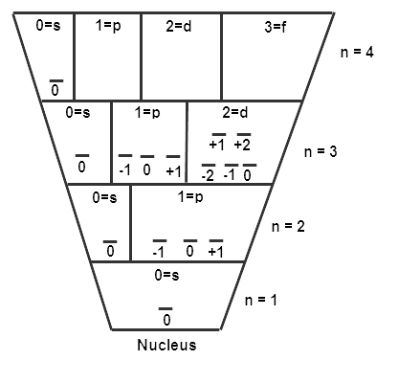

  - Assuming the atom is neutral, that is it has equal numbers of protons and electrons. What atom is represented by the diagram?

(c) What are the values of n, l, m_{l}, and m_{s} (n = floor; l = room; m_{l} = bed; m_{s} = direction) for each electron on the 3rd main energy level? List their values for each electron using the short hand method.

/3

- For each of the atoms shown below, (i) Draw the complete orbital (hotel) configuration to show the arrangement of the electrons in the atom. (ii) Identify whether the atom is paramagnetic (attracted to a magnet) or diamagnetic (not attracted to a magnet) (iii) Justify your reasoning in terms of the orbital configuration you drew in part (i)
Nitrogen  (i)  (ii)  (iii) | Aluminum  (i)  (ii)  (iii)
 |  | /4

